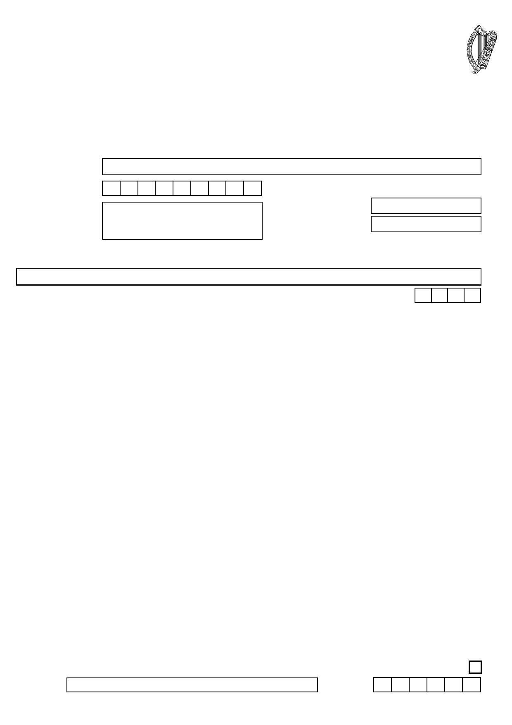
CHY3 Cert ENDURING CERTIFICATE
SECTION 848A TAXES CONSOLIDATION ACT (TCA) 1997
TAX RELIEF FOR DONATIONS TO ELIGIBLE CHARITIES AND OTHER APPROVED BODIES
This form should be completed by donors who are individuals in respect of donations made on or after
1 January 2013.
N.B. You should not complete Form CHY4 (Annual Certificate) for a tax year if you have completed, or
intend to complete, a Form CHY3 for the same year.
PLEASE REFER TO THE NOTES OVERLEAF BEFORE COMPLETING THIS FORM
COMPLETE IN BLOCK LETTERS
PART A
Name of Donor:

PPS Number:
Address: Phone No.:
Email Address:

PART B
Name of eligible charity or other approved body (hereinafter referred to as an approved body):
Enable Ireland

First tax year to which this certificate applies (cannot be earlier than 2013): 2 0 2
PART C
- I certify that this certificate is valid for the tax year specified in Part B and each of the four following tax
years, unless I notify the approved body of its earlier cancellation.
- I understand that the approved body referred to in Part B may apply to the Revenue Commissioners for tax
relief under section 848A TCA 1997 in respect of donations made by me to that body during the lifetime of this certificate and that any tax repaid to the body shall not be repaid to me or to any other approved body.
- I grant permission to the approved body referred to in Part B to use my PPS Number for the purpose of
claims for tax relief under section 848A TCA 1997 in respect of donations made by me to that body during the lifetime of this enduring certificate or a renewed enduring certificate.
- I understand I must advise the approved body immediately of any change in my circumstances that would
affect the body's entitlement to claim tax relief in respect of my donations.
- I am aware that for the purposes of tax relief under section 848A TCA 1997 on donations to an approved
body-

(a) (b)

(c)

(d)

(e)

(f)
I must be resident in the State for each tax year in which I make a donation.
A donation, or donations, must amount in aggregate to at least €250 in a tax year and be in the
form of money and/or designated securities and that tax relief will not apply to the aggregate of my donations to an approved body or bodies in a tax year in excess of €1,000,000.
Neither I, nor any person connected with me, can receive a benefit from the approved body in
consequence of making a donation.
A donation cannot be subject to a condition as to repayment nor can it be conditional on, or
associated with, the acquisition of property by the approved body other than by way of gift, from me or a person connected with me.
The amount of my aggregate annual donations to an approved body (or bodies) with which I am
associated (see Notes) will be restricted to an amount equal to 10% of my total income for the tax year in question and tax relief will not apply to any donations in excess of that amount.
I must pay income tax and/or capital gains tax for any tax year in which I make donations of an
amount equal to the income tax on the grossed up amount of the donations in order for the approved body to receive a refund of tax (see Notes).

Please tick the box if you are associated with the approved body named in this certificate (see Notes)

Signature:
Date:
(DDMMYY)

PLEASE FORWARD YOUR COMPLETED CERTIFICATE TO THE APPROVED BODY REFERRED TO IN PART B.

