Community Services and Initiatives
Contents
General Community Services and Initiatives 2
Campaigns 9
Hairdressers and Barbers 12
Paediatric dental practice’s 14
Sensory friendly shopping initiatives 17
Inclusive Sports and Activities 19
Support Groups 31
Walks around Meath 33

General Community Services and Initiatives
St. Patrick's Festival Relaxed Parade Space Applications Now Open   | - Within the Relaxed Parade Space, there will be extra space to allow freedom of movement to those who need it, limited additional seating, dedicated sensory areas, some entertainment before the Parade, accessible toilet areas, private break areas, and a cloakroom for larger bags and buggies etc.  - Families who wish to avail of the Relaxed Parade Space are asked to register their interest via ST. PATRICK'S FESTIVAL RELAXED PARADE SPACE APPLICATION (by Thursday 13 February at 5pm. If you have any issues or queries regarding this form, please contact us on info@stpatricksfestival.ie  - See more info on: https://stpatricksfestival.ie/about/latest-news/relaxed-parade-space
Down Syndrome Louth Meath Branch  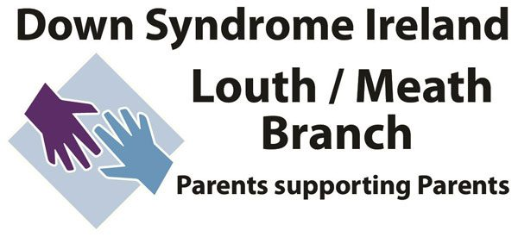 | - The Louth/Meath Branch of Down syndrome Ireland is run on a completely voluntary basis by parents of children with Down syndrome. Their aim is to support people with Down syndrome and their families in the counties of Louth and Meath.  Contact:  - Updates on events and services can be found on their website or Facebook page.  - See more at: https://dsilmb.ie/ OR https://www.facebook.com/DsiLouthMeath/
Autism Support Louth and Meath  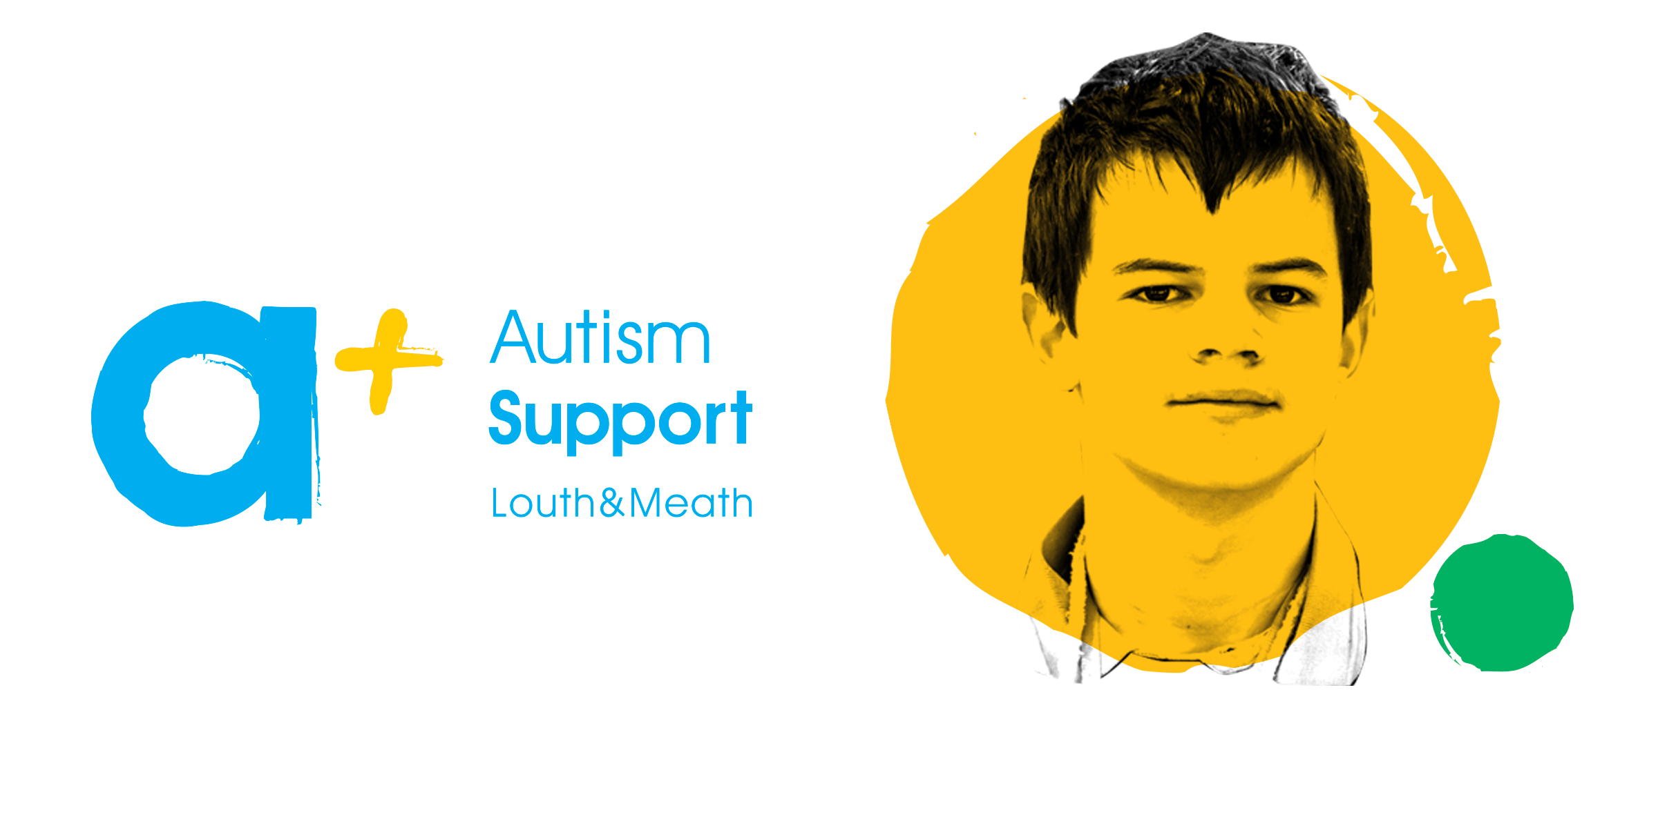  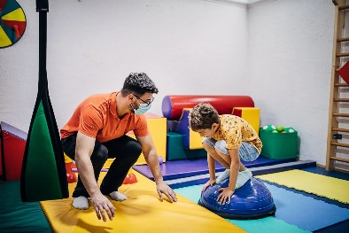   | - Autism Support Louth & Meath is a parent led support group for families of both autistic children and adults based mainly in Drogheda. They run monthly support group meetings, weekly youth clubs, training courses and family events. They provide information and advocacy, provide a network of parents and families who can support and help each other.  - Autism Support Louth,  37 Matson Lodge,  Drogheda,  Co. Louth  - Phone: 087 240 7431  - Email: info@autismsupportlouth.com  Upcoming Supports;  For more information visit: https://www.autismsupportlouth.com/news/  - Fitness Friends Term One 2025  - Fun, social fitness classes for children with autism Wednesday evenings starting 15th January for 12 weeks.  - Classes, run by our youth club staff, will take place in Drogheda ABACAS school hall on Wednesdays.  - €60 for 12 weeks, book on website; https://www.autismsupportlouth.com/news/  - Gaming Club Term One 2025  - Starting Monday 13th January for 10 weeks  - This is a fun social gaming club based in the Drogheda ABACAS School in Congress Avenue playing a variety of individual or group games on our on-site Nintendo Switches  - €50 for 10 weeks, book on website; https://www.autismsupportlouth.com/news/  Contact:  - https://www.autismsupportlouth.com/  - Facebook; https://www.facebook.com/DroghedaABACASSchool/  - For updates on events please see the ‘News’ section of their website. Some supports that took place in 2024 are coffee mornings, gymnastic classes, parent supports, gaming clubs and fitness friends.
The Salt rooms Ratoath    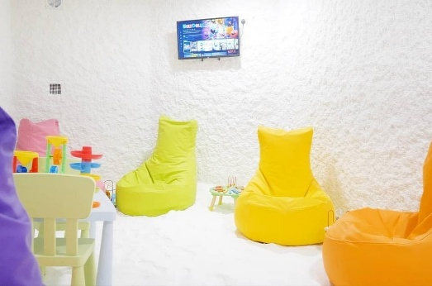 | - Salt Therapy is a completely natural, non-invasive, and drug-free treatment where dry salt aerosol is passively inhaled in a specialty constructed salt room.  - Salt rooms provide a plethora of healing properties to address a variety of conditions, from respiratory issues to skin conditions, in a relaxing environment.  - For Adults & Children: Asthma / Bronchitis, Cystic fibrosis / Ear Infections, Common Cold / Skin Conditions, Smokers’ Cough / Skin Aging, Swelling & Inflammation, Allergies / Sinusitis, Long Covid Recovery.  - Opening hours  Tuesday – Friday 10am – 8pm  Saturday 10am – 5pm  Sunday 10am – 4pm  Contact Information:  - Address: The Salt Rooms, Unit 8 The Village Centre Ratoath, Co. Meath  - Tel: 087 921 3659  - Email: info@thesaltrooms.ie  - Website: https://thesaltrooms.ie/
Delta Sensory Gardens   | - TripAdvisor often describes it as ‘an oasis of peace and tranquillity’  - Located on the outskirts of Carlow town, the gardens are set on 2.5 acres of land with 16 interconnecting, themed areas which are accessible for people of all abilities.  Contact:  - Strawhall Estate, Carlow, Co. Carlow, Ireland  - Tel:(0) 59 914 3527  - Website; https://deltasensorygardens.ie/
VUE Cinema – Sensory Friendly Screening   | - The VUE cinema group offer sensory friendly screenings on various dates/times. These friendly film screenings are sensory friendly with the sound reduced, lighting dimmed and no adverts or trailers. It is okay for guests to move around and make noise in the cinema. To access what films are available, select the cinema location and add the filter ‘Autism Friendly’.  - Locations include - Ashbourne and Liffey Valley  Contact (Ashbourne):  - Website: https://www.myvue.com/cinema/ashbourne/whats-on#accessibility  - Tel: 0345 308 4620*  Contact (Liffey Valley)  - Website: https://www.myvue.com/cinema/dublin/whats-on  - Tel: 1890 800 705*
Odeon Newbies   | - Selected Odeon cinemas are running baby friendly screenings of latest releases. Screenings include softer volume, dimmed lighting intended to create a soothing environment for both baby and child. Screenings are specifically for parents and babies so it is understood that they may not stay completely quiet throughout the film.  - Participating cinemas include Blanchardstown, Cavan, Charlestown, Coolock, Newbridge, Naas, Stillorgen, Limerick, Point Square, Portlaoise and Waterford.  Contact:  - Contact details for all participating cinemas can be found on their website: https://www.odeoncinemas.ie/offers-membership/odeon-newbies/
The Solstice Arts Centre   | - The Solstice Arts Centre Navan holds Autism Friendly screenings of popular children’s films. Updates on events are posted on their website under ‘News.’  - Solistice Art Centre also have a sister theatre in Trim called ‘Swift Cultural Centre’. Updates on events are posted on their website under ‘News.’  Contact (Navan):  - See more at: https://solsticeartscentre.ie/news/  - Tel: 046 909 2300  Contact: (Trim):  - See more at: https://swiftculturalcentre.ie/  - Tel: 046 908 7000
Navan Library/ Trim Library  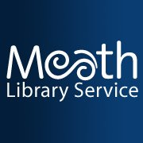 | - Various libraries around Meath offer events or times that are sensory friendly.  - Some libraries rent out sensory toys or equipment for free and have sensory rooms on site  - Navan Library have a Sensory time on Saturdays from 2.00-5.00pm. It has a designated sensory space for neurodiverse people to avail of while visiting the library. Toys include the following: Beanbags, Colour changing light cylinder, Vibrating Massage Tube, Pop up blackout sensory den, Vibrating Massage Tube, Senseez Sensory Pillow (Orange), Muffy Black/White striped headphones, Mud Ball – set of 3, Green Two Bulb Tracker and Squidgy Sparkle Fidgets (set of 5  - To see more visit: https://www.meath.ie/council/council-services/libraries/sensory-time-at-navan-library  - Trim Library have Magic Table Available and Rental of Sensory Toys  - To see more visit: https://www.meath.ie/council/council-services/libraries/general-library-services/community-group-services/magic-table  - Social Story with visuals available via their website  Navan Library:  - Website: https://www.meath.ie/amenities/community-facilities/navan-library  - Email: navanlib@meathcoco.ie  - Tel: 046 9097361  Trim Library:  - Website: https://www.meath.ie/amenities/community-facilities/trim-library  - Email: trimlib@meathcoco.ie  - Tel: 046 9436063
Magic Tummy time  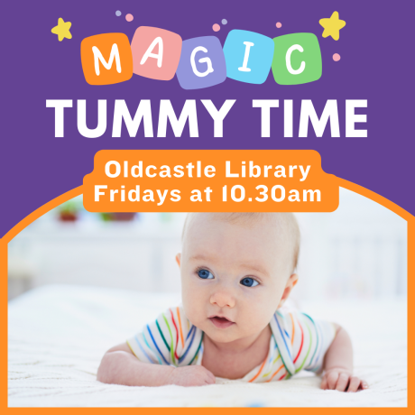 | - Magic Tummy Time is a special time for babies who have not started to crawl yet. Babies can play beneath the beautiful light projections of our interactive Tovertafel console whilst parents and minders get to know each other.  - Available in all meath Libraries, start times and start dates are subject to each library
East Meath Civic Centre  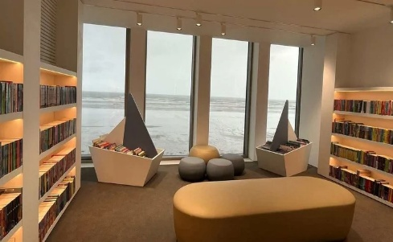  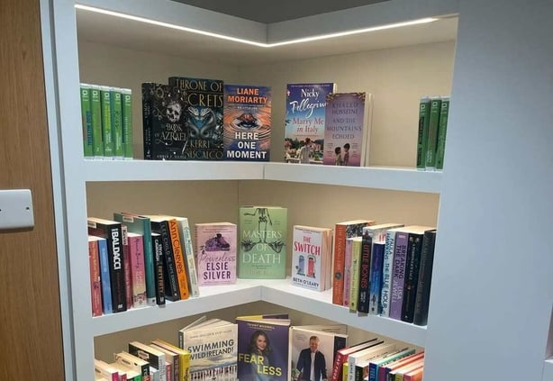 | - The East Meath Civic Centre (EMCC) in Bettystown includes two floors of library space as well as changing facilities for beachgoers, community meeting rooms and public toilets.  - The new development will accommodate the first public sensory room in the county and be the first library in Meath to offer users free access to the latest in 3D technology and group study pods to students.  - Outdoor heated showers, a water station and beach wheelchairs will also be provided.  - The new 950-square metre, four-storey building is situated on the beachfront and was solely funded by Meath County Council  Website: Meath County Council Officially Open €10 Million State-Of-The-Art East Meath Civic Centre in Bettystown | Meath.ie
Inspire together   | - Inspire Together is a therapy and sensory centre dedicated to supporting children with extra needs. We provide a welcoming, inclusive space where every child’s potential is nurtured through tailored therapeutic services.  - They offer bookable sensory rooms and movement rooms.  Contact:  - Location: Saint Joan’s House, St Joan’s Industrial Estate, Ballymount D22 NP49  - Phone: 083 333 5319  - Email: info@inspiretogether.ie  - Website: https://inspiretogether.ie/shop/
BeeUtiful Minds  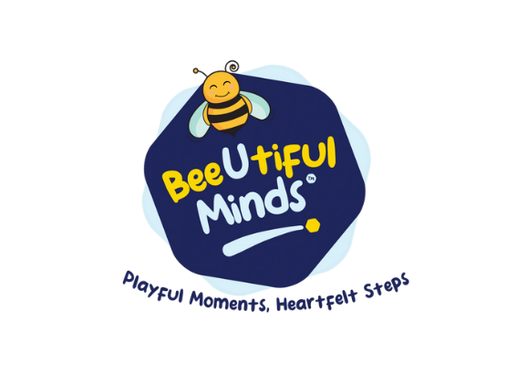 | - BeeUtiful Minds offers neuroaffirming services for families.  If your family has members who are / might be autistic, ADHD, gifted and /or with learning difficulties, a.o. or if mainstream parenting advice doesn't seem to be working, BeeUtiful Minds can offer support.  - They are based in Donabate and Swords and can offer supports remotely as well. Alainn Stables are based in Duleek, Co. Meath.  - They offer parent workshops/ coffee mornings, and they run playgroups and therapeutic riding classes in Duleek and playgroups and parents’ trainings in North Co. Dublin.  Contact:  - Tel: 086 79 234 90  - Email: info@beeutifulminds.ie  - Website: https://beeutifulminds.ie/

Campaigns
As I Am and TFI  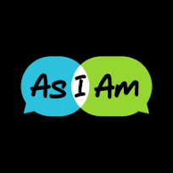   | Transport for Ireland (TFI) together with As I Am, Ireland’s Autism Charity, have a campaign called “Prepare me …. As I Am … for public transport”.  This aims to provide Autistic people with helpful tools to assist them using public transport.  - The website linked below has a library of resources to prepare and assist Autistic people to use public transport including:  - Activity Packs  - Information cards and visual guides  - How-to Videos  Website: https://www.transportforireland.ie/accessibility/as-i-am/
AsIAM Family Programme – Summer Meet Up’s on-line or in-person | - Our Child and Family Support Programme supports Autistic children, teenagers and families. It provides a safe and secure space where they can connect and share their interests and experiences, and where they can have their needs acknowledged. These spaces are relaxed, fun, and show our community that they should never be afraid to ask for adjustments to meet their needs!  - Important update regarding the AAC Support Programme  We appreciate many more families would like to be involved in the AsIAm AAC Support programme. At present the programme is at capacity but we will continue to keep our community updated on any changes. If you would like to keep up to date on this and all of AsIAm's work you can sign up to our newsletter at the bottom of this page.  Link to register for family programme: As I Am | Ireland's Autism Charity | Child & Family Support
Just A Minute (JAM) Cards  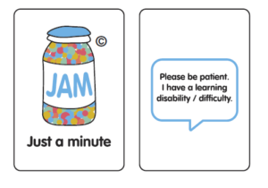 | - Card that indicates the person needs additional time and patients from the service provider during public or social situations  - Accepted in Ireland in various business:  - Transport for Ireland Services (Bus Éireann, Dart, Luas, Dublin Bus, Iarnród Éireann, and TFI Local Link.  - Some grocery stores: Lidl, Eurospar, and Spar  - Banks: AIB and BOI  Website: https://www.jamcard.org/
Important Traveller Lanyard/Wristband  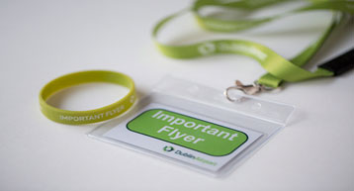 | - A wristband/lanyard that can be shown to Dublin Airport Staff (E.G. Customer Care/Security) for assistance while travelling through the busy airport.  - Assistance can be given when negotiating through security, passport control or any area where you may encounter queues or crowds.  - Must be booked in advance of travel.  Website: https://www.dublinairport.com/accessibility/travelling-with-autism
Employability   | - Company that provide job seekers with the employment assistance and advice services needed to establish financial independence, whether that be fulltime employment or training  - EmployAbility | Seetec Ireland
Sunflower Lanyard    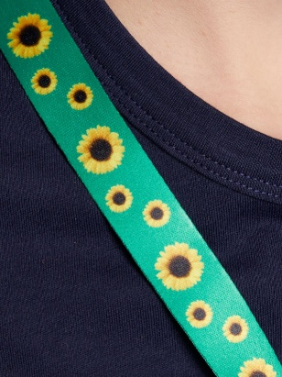 | - The Hidden Disabilities Sunflower is a simple tool for you to voluntarily share that you have a disability or condition that may not be immediately apparent – and that you may need a helping hand, understanding, or more time in shops, at work, on transport, or in public spaces.  - Since its launch in 2016, businesses from every sector have been joining the global Sunflower network - ranging from retail, travel and tourism, transport including over 200 airports - as well as railway networks, coach and bus services and ferries, education (universities, schools and colleges), healthcare, central and local government agencies to football teams, theme parks, theatres and financial institutions.  - The Sunflower has now been launched locally in Australia, Belgium, Brazil, Canada, Denmark, Ireland, Latin America, the Netherlands, New Zealand, the UK, the UAE and the USA.  Contact:  - Website: https://hdsunflower.com/us/  Shop: https://hdsunflower.com/us/shop.html

Hairdressers and Barbers
Specialised Barbers and Hairdressers   | - Barbers and Hairdressers Specialised in supporting Autistic Children  - See resources online: https://www.autismsupportlouth.com/resources-directory/community/barbers-and-hairdressers/  Meath:  - KLO Haircare –  - Hairdresser / Barber: Kerry O’Neill  - Mobile haircare Meath.  - Facebook; https://www.facebook.com/people/KLO-Haircare/100077997301984/  - Instagram; https://www.instagram.com/klo_haircare/  - The Grafton Barber Ashbourne –  - Sensory haircuts by appointment  - Tel: 01 801 0666  - Website: www.graftonbarbers.com  Navan:  - Castle Barbers –  - Unit 10, Blackcastle Shopping Centre, Blackcastle, Navan, Co. Meath, Ireland  - Tel: 086-8134474  - Ask for Linda (works Wed - Sat)  - Book here: https://www.fresha.com/lvp/castle-barbers-wrgkKv  - Chop Chop Barbers –  - 9 Watergate Street, Navan, Co. Meath  - Tel: 086 843 0015  - Ask for AnneMarie  - Crew Barbers Kids Club –  - Crew Barbers Kids Club, The Forge, High Street, Trim, Meath, C15 C590, Ireland  - Ask for Caroline  - Tel: 046 90 50795  - Website: crewbarber.ie  - Jacksons Barbers –  - Fair Green, Navan  - Tel: 086 852 8153  - Facebook: Jackson's Barbers | Navan | Facebook  Dundalk:  - Renegade 13  - Unit 2 Shorts Court Clanbrassil Street , Dundalk, Ireland  - Email: e_h_95_@hotmail.com  - Website: https://renegade13maleimage.nearcut.com/  - Signature Kids  - 69 Clanbrassil Street, Dundalk  - Tel: 083 466 7243  - Website: https://signaturehair.ie/pages/signature-kids  - The Hair Shop  - Williamsons Mall, Francis Street, Dundalk, Ireland  - Tel: (042) 933 1244  - Email: hairshopdundalk@gmail.com  Drogheda / bettystown:  - Southgate Barbers  - Southgate Shopping Centre Drogheda, Co. Meath  - Tel: 041 981 8177  - Ask for Darren  - Studio 5 Barbers  - Unit 5G Eastham Rd, Anchorage, Bettystown, Co. Meath, A92 E896  - Tel: 089 941 1057  - Ask for Malek  - The Grafton Barber (Drogheda) –  - Sensory haircuts by appointment Drogheda  - Tel: 041 984 1733  - Website: www.graftonbarbers.com

Paediatric dental practice’s
HSE Advice   | - Dental care for patients with extra needs  - Some patients may need extra support to get dental care. We call these patients 'special care patients'.  - For example, people with an intellectual, physical or sensory disability who have problems attending a regular dental surgery.  - Special care patients may be treated at the HSE dental clinics. But in some cases, their treatment may need extra support.  - The HSE Dental Service may refer you for treatment under sedation, or for general anaesthetic in a hospital.  - For routine or emergency dental treatment of special care patients, contact your local HSE dental clinic.  - Website: https://www.hse.ie/eng/services/list/2/dental/
Happy Teeth Paediatric Dentistry   | - Located in Lucan, Co.Dublin  - Paediatric dentistry practice  - Videos and photos of their building and what to expect on your first visit.  Contact:  - Phone: 01 645 9378  - Email: reception@happyteeth.ie  - Website: https://happyteeth.ie/blogs/our-blog/preparing-your-child-for-their-visit
Friel and McGahon Dental   | - Located in Dundalk Co.Louth  - Child friendly practice  Contact  - Tel: (042) 933 6214  - Email: appts@frielandmcgahon.ie  - Website: https://frielandmcgahon.ie/kids/ https://frielandmcgahon.ie/kids/
Ratoath Dental and implant centre  | - Located in Ratoath  - Child centred practice  Contact  - Tel: 01 8256983  - Email: info@ratoathdental.ie  - Website: https://ratoathdental.ie/your-childs-first-visit-to-the-dentist/
Frazer Dental   | - Kingscourt, Co.Cavan  - Nervous patients & children very welcome. Their practice is friendly, modern & homely.  Contact  - Tel: 085 788 7014 OR 042 966 8929  - Website: https://frazerdental.ie/
Pierse Dental   | - Located in Trim, Co. Meath  - Check-ups for primary school children under 12 years are free  Contact  - Tel: 046 943 1156  - Website: https://www.piersedental.ie/Treatments/Children-Dentistry
Boyne Dental (Navan, Dunshaughlin and Maynooth)   | - It is important that children have a great introduction to dental treatment and feel comfortable from their very first visit. Boyne Dental creates fun activities and a happy environment to eliminate any fears they might have about coming to the dentist.  Contact (Navan)  - Tel: 0469028683  - Email: enquiries@boynedental.ie  - Website: https://boynedental.ie/navan_location/  Contact (Maynooth)  - Tel: (01) 6289284  - Email: maynooth@boynedental.ie  - Website: https://boynedental.ie/maynooth/  Contact (Dunshaughlin)  - Tel: 01 8040290  - Email: dunshaughlin@boynedental.ie  - Website: https://boynedental.ie/boyne-dental-dunshaughlin/  (01) 628

Sensory friendly shopping initiatives
Supervalu Autism Friendly Shopping   | - Weekly time dedicated to a sensory friendly shopping environment. Locations include: Navan, and Trim.  - Navan: Monday 9:30am-10:30am  - Trim: Tuesdays 7pm-9pm  Contact  Website: https://supervalu.ie/real-people/autism-friendly/shops
Lidl Autism Friendly Shopping   | - Weekly time dedicated to a sensory friendly shopping environment  - 6-8pm on Tuesdays  - Locations: Bettystown, Dunshaughlin, Ashbourne, Balbriggan, Clonee, Navan, and Trim  Website: https://www.abettertomorrow-lidl.ie/autism-aware-store/
Aldi Autism Friendly Shopping   | - Weekly time is dedicated to a sensory friendly shopping environment. At 6:30-8:30pm on Tuesdays  - Across all 156 Aldi locations in Ireland;  Contact  Website: Autism Friendly hours at Aldi | CHO7 Children’s Disability Network Teams
Pennys Autism Friendly Shopping | - Weekly time dedicated to a sensory friendly shopping environment  - First hour of trade on Sundays  - Locations: Blanchardstown, Navan, and Liffey Valley  Contact  Website: https://www.primark.com/en-ie/autism-friendly

Inclusive Sports and Activities
Active Superstar Club   | - Active Superstars is made up of games, challenges, activities and sports such as Boccia, bowling, boxercise, balloon games, dance, parachute games, ball games and more. We work on building and developing skills such as gross and fine motor skills, hand eye coordination, strength and agility.  - All disabilities age 7-14 years Superstar Club, Sundays at Sport Ireland Campus Blanchardstown.  Contact:  - Website: https://www.sportirelandcampus.ie/active-superstars-club  - Tel: 016464300  - Email: sales@sportirelandcampus.ie
Autism Class Swimming Lessons | - Our Autism Class Swimming Lessons cater for children 4 years of age to teens. The lesson is structured in a way that suits the development of the child.  - Having the adult in the water allows the swimmer to feel supported. This will also teach the adult supports and holds that they can take with them wherever they go. This structure allows a strong bond to be created between swimmer and adult in a more relaxed quieter environment under the watchful eye of our Swim Ireland Level 2 for Autism qualified teachers.  - Based in Ireland Campus, Blanchardstown.  Contact:  - Website: https://www.sportirelandcampus.ie/autism-class-swimming-lessons  - Email: Amandawynn@sportirelandcampus.ie
Inclusive TAG rugby – Blue Dragons  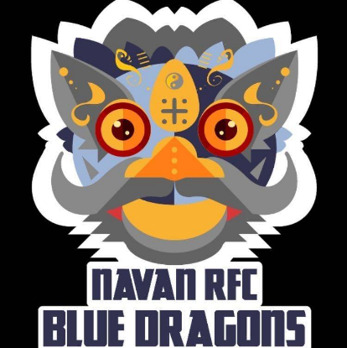 | - Navan RFC Inclusive Tag Rugby Team train every Sunday morning at 10am.  - U18 TAG rugby team  - If you would like to learn more about Inclusive Rugby in Meath please contact Sports Inclusion Disability Officer Terry Donegan on tdonegan@meathcoco.ie  Contact:  - Gerry Sweeney (Head Coach)- 0867865007 OR gersweeney@gmail.com  - Facebook: Navan RFC Inclusive Rugby Team https://www.facebook.com/people/Navan-RFC-Inclusive-Rugby-Team/100070119122464/#
Leinster Rugby Inclusion Camps Navan RFC   | - Children with all disabilities aged between 8 to 12, providing them with a fun-filled three days of rugby during the summer holidays.  - The camps are focused on adapting rugby to meet the needs of camp-goers to maximise enjoyment and learning to play.  - Navan RFC Facebook Page: Navan RFC  - If you have any further questions, please contact Leinster Rugby’s Spirit Officer, Stephen Gore- stephen.gore@leinsterugby.ie  Website: https://www.meathsports.ie/inclusive-sports/inclusive-rugby/
Inclusive Boxing   | - Inclusive Boxing sessions based all over meath.  - Visit website for more information: https://iaba.ie/club-zone/inclusion-boxing-in-iaba/  OR Contact Bettystown Boxing club:  - brucy@eircom.net  - 0879936339
BOUNCE N BEYOND TRAMPOLINE PARK   | - Based in Ballyboughal, County Dublin.  - They are open Wednesday to Friday 3pm – 8pm Saturday to Sunday 10am – 8pm  - Sensory Hours. Age 5+. 10 euro Wednesday and Sundays 5.30pm to 6.30pm  - Sensory Room on site  - Soft play Area for under 5s  Contact:  - Phone: 087 601 7698  - Email: admin@bouncenbeyond.ie  - Website: https://ecom.roller.app/bouncenbeyond2/tickets/en/product/973468
Best Of Mates   | - Best of Mates offer a therapeutic area of relaxation and stimulation for children with a sensory playroom based on the four principles of smell, sound, sight and touch. The room is complete with specialised sensory activity equipment, sensory lighting and they even have an exotic fish tank on display.  Contact:  - Kells Business Park, Cavan Road, Kells, Co. Meath  - 046 929 3432  - Website; https://bestofmates.ie/
SK Parkour   | - Parkour classes in Dundalk BlackRock, Ardee, Drogheda, Ashbourne, Navan, Kells, Wilkinstown, Ashbourne  - Parkour classes for children with Autism or ADHD in Ashbourne  - Contact: https://www.facebook.com/p/SK-Parkour-100063586269772/  Email: sergiy621@gmail.com
Messy Adventures   | - Messy Adventures provide interactive, and child led learning experiences through play  - They offer weekday messy and sensory classes for babies and toddlers across North Dublin, including Clontarf, Malahide, and Swords.  - Social story via website link  Locations and Supports:  Messy play:  - Malahide, St Sylvester’s Pastoral Centre  Main Street, Malahide (next to the train station)  - Grange Woodbine Club  Raheny Road  - Swords, Applewood Community Centre  Castleview Lawns, Bunbury Gate Ave  Google doesn’t always pick up the venue, we are next to Swords Educate Together School and opposite the new Miller’s Glen estate.  Role Play Village:  - The Riasc Centre  Feltrim Road, Drinan, Swords, K67 PX85  - Terenure Sports Club  54 Terenure Road, Terenure, Swords, D6WX265  - Malahide Rugby Club  Estuary Road, Seatown East, Malahide  - St Declans National School  Bourne Avenue, Ashbourne, A84 KT02  Contact:  - Email: hello@messyadventures.ie  - Call: 085 883 9480  - https://www.messyadventures.ie/
The Brickx Club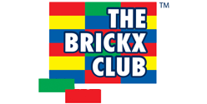 | - The Brickx Club is a creative brick building and social activity club for girls and boys. There are a number of clubs located across Ireland. They run pre-school clubs, after-school clubs, workshops and parties as well as Easter, summer and midterm camps.  - Smaller groups are run catering for all abilities. These take place in special schools either as part of the school day or as an after-school activity.  Contact:  - See More at: https://www.thebrickxclub.com/  - Rathoath, Dunshaughlin & Ashbourne area Contact: brickxclubrachel@gmail.com
Sensory Sunday (Sensory Play 4 all)  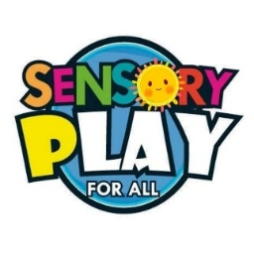 | - Sensory play classes are stay and play classes that run for 1 hour, for children aged 1 to 8 yrs.  - The sensory play classes include Messy Play, Sensory Play, Floor Games, Toys and Refreshments  - Based in Navan, Co. Meath  Contact  - Facebook: https://www.facebook.com/Sensoryplay4all/  - Instagram: https://www.instagram.com/sensoryplay4all/#
Ship Shape Play  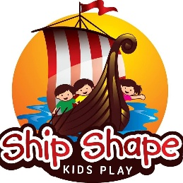 | - Ship Shape Kids Play has over 10,000 sq. ft. of soft play activities for kids from 1 year to 11 years of age.  - Based in Castleknock  - Less busy early in the morning  Contact:  - Website: https://shipshapekidsplay.com/  - Email: Shipshapekidsplay@gmail.com  - Tel: (01) 829 4123
Oldtown Riding Stables   | - Horse riding lessons based in Wyestown, Oldtown, North Co. Dublin.  - They are a family run riding stables that have therapeutic riding available for ages 3+.  Contact  - Website: https://www.aire.ie/index.php/riding-centres/list-centres?view=article&id=443&catid=32  - Phone: 01 8354 755  - Email: sheenagoodwin@yahoo.co.uk
Ballustree Equine Therapeutic center   | - Therapeutic riding aims to achieve goals that enhance physical, emotional, social, cognitive behavioural and educational skills. Depending on needs, these sessions are delivered in the arena or on the sensory trail.  - Based in Oldtown, County Dublin  Contact:  - Website: https://balcultrystables.ie/equine-assisted-therapy/  - Enquires to Catriona text @086 052 8313 or email us balcultrystables@gmail.com
Ability Equine Assisted Therapy   | - Our services include Therapeutic Horse Riding, Children’s Camp, Carers mornings and Stable Management  - Based in Castletown, County Meath  Contact:  - Website: https://aeat.ie/  - Tel: 0861594997  - Email: info@aeat.ie
Clonalvy Stables | - Clonalvy Stables Therapy Riding Center is in the heart of the countryside on the Dublin Meath boarder in Garristown.  Contact  - Address: Hammondstown, Garristown, A42DH72  - Telephone: 0872256783 - Joy  - Facebook: https://www.facebook.com/p/Clonalvy-Stables-100093654344342/#
Brookfield Stables   | - Brookfield Stables run summer camps and horse riding lesson for all children with a variety of needs.  - Hanlonstown, Navan, Co Meath.  Contact  - See more at: Brookfieldstables.ie  - Tel: 087 138-1716  - Email: info@brookfieldstables.ie
Riding for Disabled Association Ireland   | - The RDAI is an Irish voluntary organization who offer therapeutic and recreational riding or carriage driving to people with a physical or intellectual disability. The organization runs weekly lessons and classes in Pelletstown Riding Centre and Kells Equestrian Centre  Contact  - Contact: Helena O’Reilly  - Email: helenaoreilly@eircom.net
The Ark Puddenhill   | - Indoor play centre, animal farm, and outdoor play grounds. Suitable for children up to 10 years old.  Contact  - Moorepark, Puddenhill, Co. Meath, A42 Y046  - Tel: 046 906 7337  - Email: info@thearkpuddenhill.ie  - See more at: https://thearkpuddenhill.ie/
Huckleberry Den   | - Huckleberry Den Navan is a soft play adventure Centre suitable for toddlers and children up to 10 years. Special needs events are run once a month for children with special needs and their siblings. Parent and toddler mornings take place every Thursday.  Contact  - See more at: https://huckleberrysden.ie/  - Tel: 046 909 3377
My Little Play Home  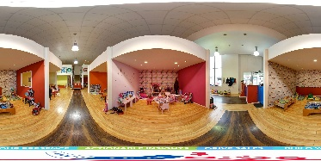 | - Soft play center for children aged 1 – 11 years in Drogheda  - Quite Times – Wednesday and Thursday 10am-12pm  Contact  - mylittleplayhomeltd@gmail.com  - Facebook: MYLITTLEPLAYHOME  - 085-820 8303
Airbound Trampoline Park   | - Trampoline Park  - Silent Hours between 6pm and 7pm (€6 entry + €2 for socks)  - Regular Hours: €12 + €2 for socks  Contact  - info@airbound.ie  - https://www.airbound.ie/  - Unit 19 Northlink Business Park , Coes Road, Dundalk, Co. Louth, A91HWT7  - 042-933 3433
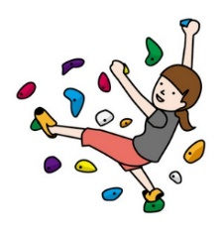  Awesome Walls | - Rock climbing / Bouldering Centre  - Sensory Friendly Times: 10am-5pm weekdays  Contact  - dublin@awesomewalls.ie  - https://awesomewalls.ie/dublin/  - Unit 6, North Park Business Park, Finglas, Dublin, D11 YP40  - (01) 880 0088
Emerald Park   | - Amusement park that accepts JAM card and Purple Card  Contact  - https://www.emeraldpark.ie/  - Kilbrew, Ashbourne, Meath, A84 EA02  - (01) 8351999
Aura Leisure Centre   | - Aura swimming pools provide swimming instructors trained in working with children with disabilities. Children are taught in mainstream classes within groups of 8. Lessons begin from 3 years of age upwards.  Contact  - Swimming lesson timetable and additional information can be found on their website  - www.auraleisure.ie  - Locations: Trim, Navan, Drogheda, Dundalk  - Trim: 046 943 8730, msrtrim@auragroup.ie  - Navan: 046 907 9950, navanlesson@aura.ie  - Drogheda: 041 987 4478  - Dundalk: 042 933 6230
National Aquatic Centre   | - Offers swimming lessons and Inclusion Camps  - 10 week swimming lessons:  - 4-10 years – Tuesdays 3pm-3:30pm  - Teen Autism – Thursdays 7:45pm – 8:30pm  - Offers seasonal multisport camps (Summer, Halloween, Christmas, and Mid- Term Breaks  - Several Sensory Areas located in the building (free to use)  Contact  - Swimming Lessons: https://www.sportirelandcampus.ie/autism-class-swimming-lessons  - Multisport camps: https://www.sportirelandcampus.ie/kids/kids-camps-2023  - amandawynn@sportirelandcampus.ie  - Tel: 01 646 43003
Active Superstars Club | - Active Superstars Club provides an opportunity for children, aged 7 to 14 years, with additional needs and disabilities to engage in different activities and enjoy being physically active. Our classes are fun, inclusive and focus on building communities, developing coping skills, improving mental and physical health.  - Location: Sport Ireland National Aquatic Centre (Fitness Studio). A lift is available to our Fitness Studios.  - Schedule: Sundays from 1:00 pm to 2:30 pm  - Cost: €150 for the full 6-week program (must be pre-booked via the 'book now' link)  - Link: Active Superstars Club | Sport Ireland Campus
Learn to Cycle   | - 6 Week program that is led by a qualified Cycling Ireland instructor with active parent involvement during the session.  - On at various intervals throughout the year and in various locations around Meath  - Learn 2 Cycle Ashbourne  - Date: Thursdays March 20th – April 24th  - Time: 4:30pm- 5:30pm  - Duration: 6 weeks  - Venue: Ashbourne Community School  - Cost: €15  Contact  - Organised by Meath Local Sports Partnership – Terry Donegan  - Email: tdonegan@meathcoco.ie  - Website: https://www.meathsports.ie/inclusive-sports/learn-2-cycle/
Run-Jump-Throw | - 6 Week program that aids in gross motor development through different sports, fun games, and obstacle challenges that are all adaptable to the child.  - On at various intervals throughout the year and in various locations around Meath  Contact  - Organised by Meath Local Sports Partnership – Terry Donegan  - Email: tdonegan@meathcoco.ie  - Website: https://www.meathsports.ie/inclusive-sports/run-jump-throw/
Inclusive Rugby | - Inclusive Tag Rugby  - Location 1: Navan RFC every Sunday morning at 10:00am  - Location 2: Ratoath FC every Saturday at 12:30  Contact Details 1:  - Organised by Meath Local Sports Partnership – Terry Donegan  - Email: tdonegan@meathcoco.ie  - Website: https://www.meathsports.ie/inclusive-sports/inclusive-rugby/  Contact Details 2:  - Contact via Facebook or Instagram
GAA-For-All  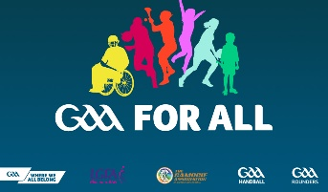 | - Inclusive GAA  - Meath: Ratoath Rockets, Oldcastle GFC, Moynalty GFC, Dunderry GFC, St Colmcilles (Bettystown), Navan O’Mahonys, Duleek/Bellewstown GFC  - Louth: St Fechins GAA (Termonfeckin), Dundalk Gaels, Naomh Mairtin (Monasterboice), Troche Emmets (Dundalk), Cooley Kickhams GFC (Carlingford), Glen Emmets (Tullyallen)  - North Dublin: Raheny GAA, St Peregrines (Coolmine), Ballymun Kickhams, St Maurs GAA (Rush), St Sylvester's (Malahide), ClG Na Fianna (Glasnevin)  - North Kildare: Cappagh GAA (Newtown), An Chill GAA (Kill)  - Contact: through teams’ website
Football-for-All  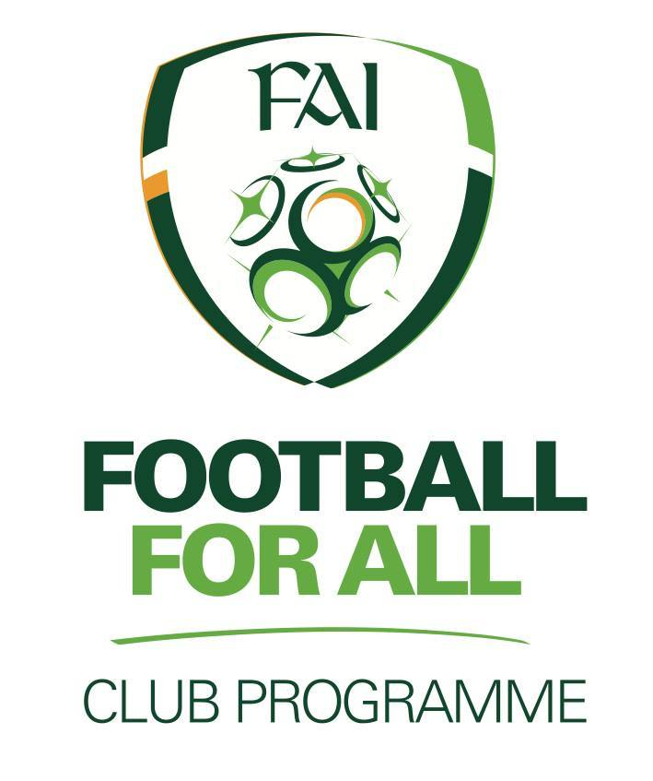 | - Weekly training sessions on in various locations around Meath  Contact  - Organised by FAI – Paddy O’Reilly  - Email: footballforall@fai.ie  - Website: https://www.fai.ie/domestic/football-for-all/football-for-all-clubs-map  - East Meath United  - Location: Minnistown Rd, Ninch, Co. Meath  - Website: https://www.eastmeathunited.ie/  - Balrath FC  - Location: Balrath, C15 H9P3  - Website: http://www.balrathgbfc.com/  - Castle Villa  - Location: Kells, A82 W578  - Website: https://castlevillameath.com/  - Enfield Celtic  - Location: Dublin Rd, Enfield, Meath  - Website: https://www.facebook.com/enfieldcelticfc/
Football-for-All: Vision Impaired Football  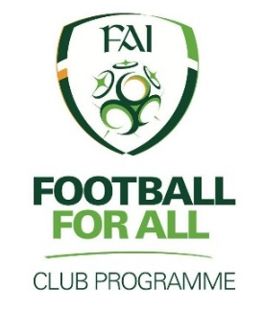 | - Weekly training sessions on in Bettystown.  Contact  - Organised by FAI – Paddy O’Reilly  - Email: footballforall@fai.ie  - Website: https://www.fai.ie/domestic/football-for-all/football-for-all-clubs-map  - Donacarney Celtic  - Location: Dun Eimear Green, Donacarney Great, Bettystown, Co. Meath  - Website: www.donacarneyceltic.com
Enjoy Tennis | - Weekly training sessions on in Kells Tennis Club on Sundays 12pm-1pm  Contact  - Richard Tuner (Kells Tennis Club Coach): 086-8524410  - Website: https://www.meathsports.ie/inclusive-sports/enjoy-tennis/
Dunshaughlin Dance   | - All classes are inclusive, they offer various dance styles for various ages.  - Dance styles include: Hip-Hop, Acrobatic Dance, Ballroom/Latin, Jazz, and Baby Boppers  Contact  - Email: dunshaughlindance@gmail.com  - Website: https://www.dunshaughlindance.ie/
D.P. Gymnastics   | - Offers 10 week blocks of classes (with trial period)  - Location: Drogheda OR Balbriggan  - Contact: (01) 690 4208  - Website: https://dpgymnasticsclub.com/
Ashbourne Gymnastics   | - Inclusive Gymnastics Classes  - When: Fridays at 5:30pm-6:30pm  - Location: Ashbourne Community National School  - Contact: 085-7663650
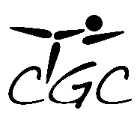 | - ‘’In September 2013 we opened a fulltime facility in Ashbourne Industrial Estate, and are constantly expanding the range of classes available. We also now run classes on Saturday morning in LeisurePoint Sports Centre, Cardiffsbridge road, Finglas.’’  - GymAble Classes for children with disabilities and we are always looking to expand our range services to suit the needs of the community.  - Contact: Janet 087-9704080  - Website: CGC Gymnastics Club  - GymAble: Please contact us to book Friday's at 3:30 and 4:15
Braveheart Martial Arts Academy  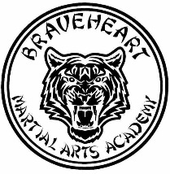 | - All classes on offer are inclusive to all children. Instructors are able to adapt the class to the child.  - Location: Oak Tree Industrial Estate, Trim, Co. Meath  Contact  - Website: https://www.facebook.com/braveheartkenpo/  - Email: tigerbren@gmail.com
Mini-Athletes   | - Inclusive strength and movement development classes that are held in various locations.  - Age Groups: 2yrs - 3½yrs, 3½yrs - 5yrs, 5yrs – 7yrs  - Locations: Navan (Claremount Stadium), Drogheda (Marian Park), Swords (ALSAA)  Contact  - Website: https://www.miniathletics.com/mini-athletics-dundalk-drogheda-and-swords-summary/
Spectrum Fitness Huntstown  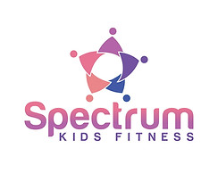 | - Spectrum Kids Fitness organises evening classes for its participants to take part in a variety of different activities each week, with the main goals of building fitness as well as developing one’s social skills and self-confidence.  - They run classes for autistic children  Contact  - 0872568678  - Facebook: Spectrum Kids Fitness
Scouts   | - All scouting groups in Ireland are inclusive and the leaders  - Locations include: Dunshaughlin (A85PN28), Dunboyne, Stamullen (K32C433), Kentstown, Donore (A92FW14) , Ratoath (A85TX29)  - Dunshaughlin: info@7thmeathscouts.ie  - Dunboyne: GLFirstMeathDunboyneScouts@gmail.com  - Stamullen: stamullensg@gmail.com  - Kentstown: 21smeath@gmail.com  - Donore: 22ndmeath@gmail.com  - Ratoath: 9thmeathratoathgroupcouncil@gmail.com
Coder Dojo  | - A volunteer organisation which helps kids learn how to program, build websites, animate games with different software programs and computer languages.  Contact  - Navan: https://www.facebook.com/CoderDojoNavan/  - Dunshaughlin: https://www.facebook.com/CoderDojoDunshaughlin1/
Duleek/Bellewstown GFC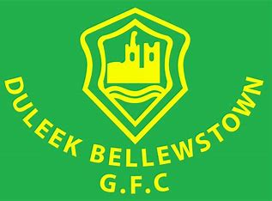 | - Duleek/Bellewstown GFC all-star sessions are fun activities for children with additional needs.  - Starting on Thursday the 9th of January from 5-6pm for 6-week blocks  - No booking needed just show up on the day  Contact  - Instagram; https://www.instagram.com/duleek.bellewstown.gfc/
Meath Sports Partnership | - Welcome to the Sports Ability Section of the Meath Local Sports Partnerships website. This section of the website contains all information relevant to Children & adults with a disability looking to participate in Sport & Physical Activity.  - Meath Local Sports Partnership set out in its strategic plan the need to promote and support the inclusion of people with disabilities in sport and physical activity through the development and implementation of a Disability Sport Action Plan. Meath LSP would encourage any group or individual looking for additional information regarding sport and physical activity for people with a disability to contact Terry Donegan below.  - https://www.meathsports.ie/inclusive-sports/
Abelfest  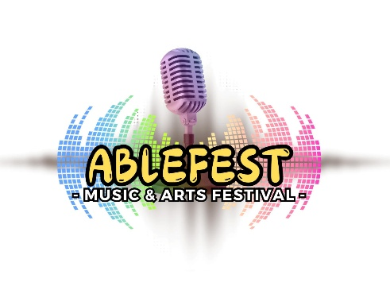 | Ablefest 2025: Ireland’s Premier Inclusive Music & Arts Festival! Get ready for an unforgettable experience at Ablefest 2025, returning bigger and better than ever! Join us on Saturday, July 26th, 2025, at Fairyhouse Racecourse, Co. Meath, for a double-headliner festival featuring the incredible Jake Carter and Johnny Brady.  Location:  - Ablefest 2025 Inclusive Music & Arts Festival 26th July Fairyhouse Racecourse Fairyhouse Racecourse – Ratoath  Dates & Times:  - Saturday 26 July 2025 at 12:00 pm  Price:  - General Admission - Adults (18+) Price: €52.00  - Children (under 18): €15.95
Artz for Kids   | A fun unique art program for children. Storytelling, Confidence building and Professional Design. We nurture imagination in follow along drawing, painting, lessons in Ireland.  Contact  - Email: Info@artzforkids.ie  - Facebook: ArtzforKids
Active Superstars Club | - Active Superstars Club provides an opportunity for children, aged 7 to 14 years, with additional needs and disabilities to engage in different activities and enjoy being physically active. Our classes are fun, inclusive and focus on building communities, developing coping skills, improving mental and physical health.  - Location: Sport Ireland National Aquatic Centre (Fitness Studio). A lift is available to our Fitness Studios.  - Schedule: Sundays from 1:00 pm to 2:30 pm  - Cost: €150 for the full 6-week program (must be pre-booked via the 'book now' link)  Link: Active Superstars Club | Sport Ireland Campus

Support Groups
SPECIAL HANDS ACTIVITY GROUP  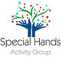 | - Special Hand Group is a community and parent-led registered charity who organise activities, camps and social events for children & young adults who have additional needs.  - Based in Kells, Meath  - Website: https://www.specialhandsgroup.com/
RARE IRELAND  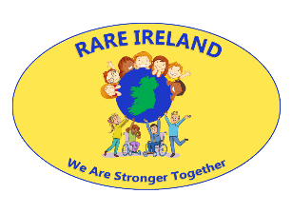 | - Rare Ireland was set up in 2017 by two mothers of daughters with rare chromosome disorders, Laura Egan and Louise O’Keeffe.  - Rare Ireland was initially set up as a Facebook support group for parents of children and young adults living with rare conditions and was successful in obtaining charity status in February 2022.  - Website: https://rareireland.ie/
TAG Meath Autism Group  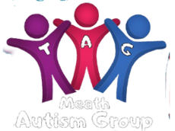 | - TAG run Junior and Senior Group Activities as well as weekly Parent Support.  - Based in Navan  - Website: https://tagmeathautismgroup.ie/
ABLE FEST   | - TradFest is a joyful celebration of Irish identity through music. Each January, it showcases the best of established and emerging musical talent at a landmark festival which is rooted in the historic and atmospheric setting of Dublin city and county.  - Annual inclusive music festival for people with additional needs.  - Instagram: https://www.instagram.com/ablefestireland/?hl=en  - Tel: 087 280 0908  - Email: ablefest@gmail.com
ARCH CLUBS   | - Social Club for people with additional needs  - Various Locations around Meath and Louth.  - Listed here: https://www.archclubs.com/clubs
SNOWFLAKES Autism Support   | - Registered Charity based in Swords.  - Parent Support, events and activities for members.  - Website: https://www.snowflakes.ie/
SPECTRUM SPIRT   | - Ratoath GAA Monthly Parent Support Group  - We are a friendly,non judgmental support group for parents and carers of Autistic children within Ratoath/Meath area.  - Instagram: https://www.instagram.com/spectrum_spirit_/?locale=zh_CN&hl=af
Trim Family Resource Centre  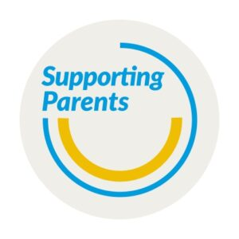 | - Trim Family Resource Centre host a Parents Support Group that meets once a month for parents of children and young people with a disability/additional needs.  - More events are planned for Autumn/Winter 2024 and details of upcoming meetings and events can be found on Trim-Family Resource-Centre Facebook page and on the Parent Support Group’s Instagram page at parentsupportgroup_meath  - You can also join our Parent Support Group email list by emailing maryrose@trimfrc.ie or caroline@trimfrc.ie  Contact:  - Facebook; https://www.facebook.com/trimfamily.resourcecentre  - Instagram; https://www.instagram.com/parentsupportgroup_meath/  - Website: https://trimfamilyresourcecentre.ie/parent-support-group/

Walks around Meath
Loughcrew   | - Time: 40-75 minutes  - Length: 3-4km trail  - Difficulty: Moderate  - Stat-point: Loughcrew Cairns Car Park
Girley Eco Bog Walk  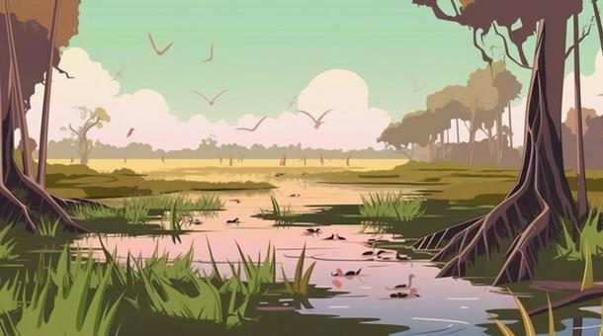 | - Time: 90-120 minutes  - Length: 6km trail  - Difficulty: Moderate  - Stat-point: Drewstown Woods, near Kells
Balrath Woods   | - Time: 10-30 minutes  - Length: 600m-1.6km trail  - Difficulty: Easy  - Stat-point: Balrath Woods Car Park
Boyne Ramparts Walk   | - Time: 2-2.5hrs  - Length: 16km  - Difficulty: Moderate  - Stat-point: Stackallen or Navan Ramparts
Mullaghmeen Forest   | - Time: 120 minutes  - Length: 6km  - Difficulty: Moderate  - Stat-point: Mullaghmeen Forest Car Park
  Summerhill Woods | - Time: 45 minutes – 1 hour  - Length: 2.9km  - Difficulty: Easy  - Stat-point: Summerhill Wood Car Park
Hill of Tara | - Time: 30-40 minutes  - Length: 5km  - Difficulty: Moderate  - Stat-point: Church Car Park, Tara Hill
Trim Castle River Walk  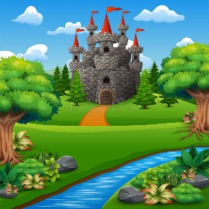 | - Time: 40 minutes  - Length: 1.5km  - Difficulty: Easy  - Stat-point: Trim Castle Car Park
Littlewood Forest Walk   | - Time: 40 minutes  - Length: 2km  - Difficulty: Easy  - Stat-point: Forest Entrance Car Park
Beaches   | - Morington Beach  - Bettystown Beach  - Laytown Beach  - Clogherhead Beach (Louth)  - Port Beach (Louth)  - Annagassan Beach (Louth)  - Termonfeckin Beach (Louth)
Website: https://www.theirishroadtrip.com/best-walks-in-meath/
Rossnaree Boyne Canal Walkway   |  | - Location: Rossnaree, Meath (Donore area)
Sonairte Eco-Centre and Gardens   |  | - Location: The Ninch, Laytown, Meath  - Open Friday-Sunday 10am-5pm  - Website: sonairte.ie
Porchfield and Talbot’s Castle Loop   |  | - Location: Trim castle car park  - Time: 30 Minutes  - Length: 1.9km trail  - Difficulty: Easy
Royal canal way: Enfield to Moyvalley   |  | - Stat-point: Enfield town  - Time: 90-120 minutes  - Length: 12.9km trail  - Difficulty: Moderate
Slane: Boyne footpath trail   |  | - Stat-point: Slane Town  - Time: 3hrs 51 minutes  - Length: 11.7 km trail  - Difficulty: Moderate
Blackwater park loop   |  | - Stat-point: Car park beside ESB networks Navan town  - Time: 25 Minutes  - Length: 1.6km  - Difficulty: Easy

Special Olympics Ireland - Sports
Special Olympics Ireland: Athletics | - Club Locations: Ashbourne, Dunshaughlin, Navan, Drogheda  - Ashbourne: Ashbourne Community Centre; Saturday 10-11am  - Dunshaughlin: Dunshaughlin Community Centre; Tuesday 6-7pm  - Navan: Claremount Stadium; Friday 7-8pm  - Drogheda: Slaugh Hall; Monday 6:45-9, Friday 8-9pm  - Website: https://www.specialolympics.ie/local-clubs/find-a-club?k=&location=32&sport=43
Special Olympics Ireland: Basketball   | - Club Locations: Navan (Arch Club), Drogheda  - Navan: Navan Arch Club, Beaufort College; Thursday 7:30-9:30pm  - Drogheda: Drogheda Institute of Further Education; Wednesday 7:30-8:30pm  - Website: https://www.specialolympics.ie/local-clubs/find-a-club?k=&location=32&sport=45
Special Olympics Ireland: Bocce   | - Club Locations: Navan (Arch Club), Drogheda  - Navan: Navan Arch Club, Beaufort College; Thursday 7:30-9:30pm  - Drogheda: Slaugh Hall; Monday 6:45-9pm  - Website: https://www.specialolympics.ie/local-clubs/find-a-club?k=&location=32&sport=46
Special Olympics Ireland: Equestrian   | - Club Locations: Kells  - Kells: Kells Equestrian Centre; Tuesday 4:30-5:30pm, Wednesday 5-6pm  - Website: https://www.specialolympics.ie/local-clubs/find-a-club?k=&location=32&sport=48
Special Olympics Ireland: Floorball   | - Club Locations: Navan (Arch Club), Navan (Royal Rovers), Ashbourne  - Navan: Navan Arch Club, St. Mary’s Hall; Wednesday 7-8pm  - Navan: Royal Rovers, Claremont Stadium; Tuesday 6-7pm  - Ashbourne: Ashbourne Community Centre; Saturday 10-11am  - Website: https://www.specialolympics.ie/local-clubs/find-a-club?k=&location=32&sport=46
Special Olympics Ireland: Football  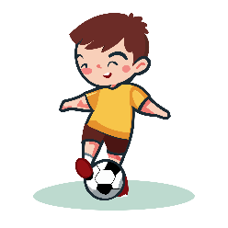 | - Club Locations: Ashbourne, Drogheda  - Ashbourne: Ashbourne Community Centre; Thursday 7-8pm  - Drogheda: Leisure Park; Thursday 7-8pm, Saturday 12-1pm  - Website: https://www.specialolympics.ie/local-clubs/find-a-club?k=&location=32&sport=50
Special Olympics Ireland: Golf   | - Club Locations: Drogheda  - Ashbourne: Ashbourne Community Centre; Drogheda: County Louth Golf Club; Thursday 11-12pm  - Website: https://www.specialolympics.ie/local-clubs/find-a-club?k=&location=32&sport=50
Special Olympics Ireland: Kayaking  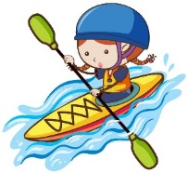 | - Club Locations: Cavan Town  - Cavan Town: Cavan Canoe Centre; Wednesdays 6:30-8:30pm (Summer Time)  - Website: https://www.specialolympics.ie/local-clubs/find-a-club?k=&location=16&sport=53
Special Olympics Ireland: Motor Activities   | - Club Locations: Navan  - Navan: Navan Arch Club (No Details-keep an eye on Facebook)  - Website: https://www.specialolympics.ie/local-clubs/find-a-club?k=&location=32&sport=57
  Special Olympics Ireland: Swimming | - Club Locations: Trim, Navan, Drogheda, North Dublin, Corduff  - Trim: Aura Leisure Centre, Trim; Wednesdays 7-8pm  - Navan: Aura Leisure Centre, Navan; Tuesday 7-8pm  - Drogheda: Drogheda Leisure Centre; Friday 6:45-8pm  - North Dublin: ALSAA; Thursday 7-8pm  - Corduff: National Aquatic Centre; Sunday 4-5pm  - Website: https://www.specialolympics.ie/local-clubs/find-a-club?k=&location=32&sport=57
Special Olympics Ireland: Table Tennis   | - Club Locations: Navan  - Navan: Navan Arch Club; Thursday 7:30-9:30pm  - Website: https://www.specialolympics.ie/local-clubs/find-a-club?k=&location=32&sport=56
Special Olympics Ireland: Tenpin Bowling   | - Club Locations: Drogheda (Navan Arch Club), Navan (Navan Arch Club)  - Drogheda: Drogheda Leisure Centre; Wednesday 7-9pm  - Navan: The Zone; Wednesday 7-9pm, Friday 6-7pm  - Website: https://www.specialolympics.ie/local-clubs/find-a-club?k=&location=32&sport=75
Special Olympics Ireland: Young Athletes Club   | - Club Locations: Dunshaughlin  - Dunshaughlin: Dunshaughlin Community Centre; Tuesday 6-7pm  - Website: https://www.specialolympics.ie/local-clubs/find-a-club?k=&location=32&sport=56

Shops for Sensory Goods and Toys
Adam and Friends   | - Adam & Friends hold a range of toys and equipment for premature babies and children with special needs. The also install multi-sensory rooms and products and child safety systems in schools and the home.  Contact  - See more at: specialneedstoys.com  - Tel: 01 899 1041  - Shop In store: Unit 10B 4, Stadium Business Park, Ballycoolin Road, Dublin 11
Sensational Kids | - Sensational Kids is service for children with special educational needs based in Co. Kildare. As part of the organisation they run a child development and learning store which stocks a range of skill building toys and therapy products and books. All proceeds from sales help towards funding occupational therapy & speech and language therapy services for children at Sensational Kids.  Contact  - See more at: SensationalKids.ie  - Phone orders: 045 520 900  - Shop In-Store: Unit F2 Kildare Business Park, Kildare Town
Sensory Kids Store | - The Sensory Kids Store is an online store that sells products to meet a child’s sensory needs. Products are listed under seeing, hearing, talking, touching, smelling, moving, feeling, learning and multi-sensory toys.  Contact  - See more at: sensorykidstore.com
Thinking Toys | - Thinking Toys is an Irish run business that sells a range of products for children with special needs or learning disabilities. Products can be viewed at thinkingtoys.ie. The business also runs annual Christmas Toy Shows in October and November.  Contact  Tel: 061 374402 or 085 889 4855  Email: info@thinkingtoys.ie
*Do not forget to check ALDI and LIDL for alternative options or search for similar toys on Amazon*

This list was jointly created with the CDNT 4 staff members, our family reps & families who attended our Family Forum in February 2025. If you have anything additional to add/remove, please do not hesitate to contact admin and we will amend same.

