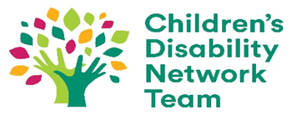
Could you be the voice of families?

Self-Nomination Form
Family Representative
For Children’s Disability Network Team 7 Family Forum

Please read the attached “Role of the Family Representative” and if you are interested in this role, we would welcome your self-nomination.

Please return to the Children’s Disability Network Manager once completed.

- Name:

- Address:

- Email:

- Phone:

- Age of your child or children with complex needs:

- What in broad terms is the nature of your child’s disability? (Optional)

Please answer the following four questions about your experience and interest in the role using less than 300 words for each question.

7. Have you been involved in advocacy on behalf of others? If so please describe.

8. Tell us about your experience of taking part in groups and committees. Include any local, social, work or professional groups as well as disability services.

9. Tell us about other relevant experience

10. Tell us about your interest in being a Family Representative on your local Family Forum and Family Representatives Group.

For the purposes of the family representative elections, I hereby EXPLICITLY CONSENT to Enable Ireland (mark with x): | Yes | No
Processing the data I have provided by completing this form

This form will be destroyed once the election process is complete and elected Family Representatives have been notified.

Signature _________________________ Date ____________

Please see attached the Data Protection Notice (also available to view online via the Privacy Policy section on Enable Ireland’s website) which includes information on your right to withdraw from providing your consent to data processing your personal information.

